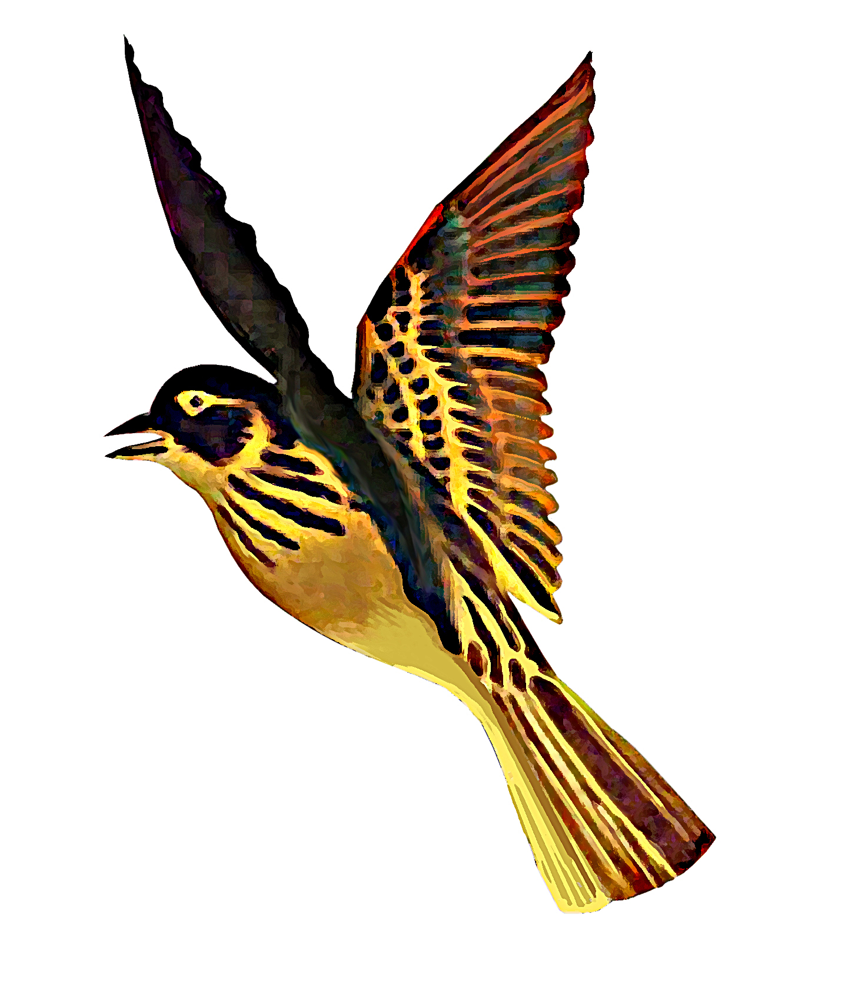
SCOIL NA FUISEOIGE

40 Gardenmore Road Belfast BT17 0DF
Guthán/Phone: 02890600227 Faics/Fax: 02890600837
_______________________________________________________________________________________

Digital Resources for learning at home: Acmhainní Foghlama digiteacha atá ar fáil ón Bhaile

Guidance for parents, guardians and students.
Treoir do Thuismitheoirí, do chaomhnóirí agus do dhaltaí na scoile

The list will be uploaded to the school website and can be accessed at www.scoilnafuiseoige.weebly.com

Logging into My School From Home.
In a search engine, type myschool. Then choose https://www.c2kschools.net and enter login details
An example of what a username and password looks like can be seen below.
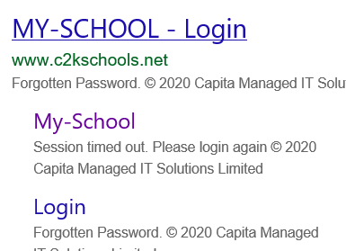
Seán Mac Gabhann

Username = smacgabhann123
Password = password1234

From MySchool, after clicking on MY LINKS, students can access Seomra Nuachta, C2k Media Library, Newsdesk and Equella. I have included some suggestions or guidance below regarding areas of interest and different tools within Seomra Nuachta

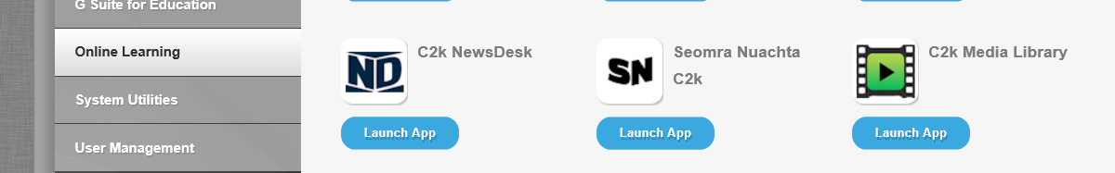

- C2k Media Library : Déan Damhsa Aire do na hUain, Máire Zepf (Lá leis na Lochlannaigh) 100 Bliain ó rugadh Roald Dahl, La na bPancóg , Scéal Marie Curie, Na Beanna Boirche, An Bríste Úr, Rainforest Song cíbearbhulaíocht, Mummfication, 3 pigs
Some videos dicusiing Covid 19 Issues
One small Step https://estream.c2kschools.net/view2.aspx?id=6901~4q~qQPgemUK Returning to Schooll https://estream.c2kschools.net/view2.aspx?id=7950~4v~6fmTEL77 F.A.C.E Covid https://estream.c2kschools.net/view2.aspx?id=7943~4x~8CS88ItS
Ag filleadh chun na scoile https://newsdesk.c2kschools.net/c/newsdesk/news/16658
https://newsdesk.c2kschools.net/c/newsdesk/news/16656
focail nua covid https://newsdesk.c2kschools.net/c/newsdesk/news/16571

- Seomra Nuachta
- Na scéalta is úire / Latest Stories: Ceangail leis an fhoclóir(Click on word and it translates it)
- Tráchtanna a scríobh: (Write your opinion in Irish)
- Vóta a chaitheamh/ Take part in a poll
- Nuacht I bhfíseáin/ Collection of Videos in Irish

- Puzáil agus Cluichí Mata/ Puzzles and Games in Irish
- Fillteáin Fíricí: Spás/ Foraoisí Báistí/ An Gorta Mór/ Tútancamán / na Lochlannaigh

- Equella: Ceachtanna Idirghníomhacha/ Interactive Lessons: Search
- Irish: Ag Fágáil an Bhaile (|An Gorta Mór) Céiliúraimís (Féilte/ Cúiseanna Céiliúrtha)
- Ceacht Ceoil don Bhonnchéim
- Cé a dhéanann Cinneadh?
- Blaiseanna an Domhain
- Cé a reáchtálann an scoil s’againne
- Carnbhal na nAinmithe
- An Fheirmeoireacht san am atá thart
- Poist Thábhachtacha I mo Phobal
______________________________________________________________________________________________

Digital Stories E-Books for Rang 1 to Rang 4 in Irish: Links to Web-Based Reading Material and E-Books
https://www.leighanois.com/index.php
Leabhair Cainte Séidéan Sí ( Ulaidh)
https://seideansi.ie/dep/files/ulster/Ce_leis.html
https://seideansi.ie/dep/files/ulster/Ce_ata_ann.html
https://seideansi.ie/dep/files/ulster/Daideo.html
https://seideansi.ie/dep/files/ulster/Teaghlach_Liam.html
https://seideansi.ie/dep/files/ulster/Fliuch_Baite.html
https://seideansi.ie/dep/files/ulster/Peata_Aine.html
https://seideansi.ie/dep/files/ulster/Na_Tri_Bhear.html
https://seideansi.ie/dep/files/ulster/Is_feidir_liom.html
https://seideansi.ie/dep/files/ulster/Daideo_ag_siopadoireacht.html
https://seideansi.ie/dep/files/ulster/Mo_phictiur.html
https://seideansi.ie/dep/files/ulster/Mo_chuid_oibre.html
https://seideansi.ie/dep/files/ulster/Ag_siopadoireacht_le_Mamai.html
https://seideansi.ie/dep/files/ulster/Am_Loin.html
https://seideansi.ie/dep/files/ulster/An_Gadai_Beag.html
https://seideansi.ie/dep/files/ulster/An_tusa_mo_Mhamai.html
https://seideansi.ie/dep/files/ulster/Ar_mhaith_leat_imirt_liom.html
https://seideansi.ie/dep/files/ulster/Cad_ata_uait.html
https://seideansi.ie/dep/files/ulster/Cad_e_ata_ort.html
https://seideansi.ie/dep/files/ulster/Ceard_ata_agat.html
https://seideansi.ie/dep/files/ulster/Eadai_Liam.html
https://seideansi.ie/dep/files/ulster/Feach_ar_Theidi.html
https://seideansi.ie/dep/files/ulster/Gug_ag_Siopadoireacht.html
https://seideansi.ie/dep/files/ulster/Is_maith_liom.html

https://seideansi.ie/dep/files/ulster/Mo_Thigh.html
https://seideansi.ie/dep/files/ulster/Nach_mise_ata_go_deas.html
https://seideansi.ie/dep/files/ulster/Ni_feidir_liom_e_a_fhail.html
https://seideansi.ie/dep/files/ulster/Rira_i_seomra_na_naionan.html
https://seideansi.ie/dep/files/ulster/Ta_an_Geimhreadh_ann.html
https://seideansi.ie/dep/files/ulster/Tabhair_dom.html
https://seideansi.ie/dep/files/ulster/An_maith_leat.html
https://seideansi.ie/dep/files/ulster/An_Nollaig.html
https://seideansi.ie/dep/files/ulster/Ar_maidin.html
https://seideansi.ie/dep/files/ulster/Broga_Chait.html
https://seideansi.ie/dep/files/ulster/Sciob_Salach.html
https://seideansi.ie/dep/files/ulster/Sciob_Dana.html
https://seideansi.ie/dep/files/ulster/Ce_ata_ag_caint.html
https://seideansi.ie/dep/files/ulster/Eoin_ar_an_Teilifis.html
https://seideansi.ie/dep/files/ulster/Sciob_agus_an_cat.html
https://seideansi.ie/dep/files/ulster/Corais_taistil.html
https://seideansi.ie/dep/files/ulster/Seomra_Nua.html
https://seideansi.ie/dep/files/ulster/Stop_an_Bus.html
https://seideansi.ie/dep/files/ulster/Na_Tri_Mhuicin.html
https://seideansi.ie/dep/files/ulster/sneachta.html
Digital E-Books Rang 4 to Rang 7
https://leighleat.com/fabhalsc%C3%A9alta FabhalScéalta Fables in Irish
https://leighleat.com/d%C3%A1nta/1 Dánta Gabriel Rosenstock Poems
https://leighleat.com/aural_learning_lessons/16 Cad é sin? Tearmaíocht
http://www.askaboutireland.ie/learning-zone/primary-students/infants/irish-infants/ Scéalta, Amhráin agus Ráithe na Bliana `Stories, Songs and Lessons about the Seasons in Irish
https://www.forasnagaeilge.ie/fuinn/an-gum/seidean-si-leabhairini-urscealta-ranga/ Scéalta rang Séideán Sí R4-7 E-Books and activities based on Reading Books

The following links direct you to Presentation made using Google Slides. It Works best using Chrome. Open the link. And click on PRESENT: If your device does not support Google Slides, the links might not work.

- An Bus Mara https://docs.google.com/presentation/d/10fqz-B4E822UIpViExazMK6xUiM7QB7xjldt4gUWZVo/edit?usp=sharing
- Leamhanhttps://docs.google.com/presentation/d/1orUmyVyDA04EXNczQ2KGg2H8zy9Po1QA3nUDPYEJHJs/edit?usp=sharing
- Na Beacha agus Béar https://docs.google.com/presentation/d/1rcxHhQcfulXUrvh9rraTfDtQtL0tQEVHGXK0NRlASQI/edit?usp=sharing
- Caisearbhán https://docs.google.com/presentation/d/1M-9W4VFlZ28AX7wI9dHFKj-6Zpf5AgW1YaTj6MmpiD8/edit?usp=sharing

Digital Resources for Supporting Reading Skills : Links to Web-Based Resources
Early Literacy Games in Irish for Children-Cluichí Bunaithe ar CLL 1-3
https://ccea.org.uk/learning-resources/clar-luathleitheoireachta-cleite/cluichi-bhanda-1
https://ccea.org.uk/learning-resources/clar-luathleitheoireachta-cleite/cluichi-bhanda-2
https://ccea.org.uk/learning-resources/clar-luathleitheoireachta-cleite/cluichi-bhanda-3
http://www.nicurriculum.org.uk/curriculum_microsite/snas_ar_sceal/cluichi-ec1/
https://seideansi.ie/rang2.php#ceim1
https://seideansi.ie/rang2.php#ceim2

Literacy Games for Rang 4-Rang 7
https://seideansi.ie/rang2/gniomhaiocht-1/Ceim%203/Na_Beacha_Meala/
https://seideansi.ie/rang2/gniomhaiocht-1/Ceim%203/Na%20Tri%20Mhian/
https://seideansi.ie/rang2/gniomhaiocht-1/Ceim%203/Cad%20e%20sin%20-%20Ulster/
http://www.nicurriculum.org.uk/curriculum_microsite/snas_ar_sceal/cluichi-ec2/
http://legacy.ccea.org.uk/curriculum/gaeloideachas/foghla%C3%AD_focal
https://seideansi.ie/rang-a-tri-se.php#

Sites and digital resources to Support Spelling in Irish

Fónaic agus Litriú Spelling and Phonics
https://ccea.org.uk/learning-resources/cod-na-gaeilge#section-9228 Cluichí Cód Na Gaeilge (Chrome)
https://leighleat.com/f%C3%B3naic/uladh_audio Fónaic Uladh
Fuaimeanna Deiridh Na gutaí fada End Sounds and Long Vowels
https://seideansi.ie/rang1/gniomhaiocht-3/a_o_u/
https://seideansi.ie/rang1/gniomhaiocht-3/e_i/
Cnuaschonsain ag tús focail Inital Consonants
https://seideansi.ie/rang2/gniomhaiocht-3/cd-dr-fr-br/
https://seideansi.ie/rang2/gniomhaiocht-3/cl-bl-gl/
https://seideansi.ie/rang2/gniomhaiocht-3/pl-sl-fl/
https://seideansi.ie/rang2/gniomhaiocht-3/gr-pr-st-tr/
Défhoghair Words with spelling Pattern -ia- -ea- -eo- -ua-
https://seideansi.ie/rang2/gniomhaiocht-3/ia-ea-eo-ua/
Deirí Coitianta Common Word endings
https://seideansi.ie/rang1/gniomhaiocht-3/an_ch/
https://seideansi.ie/rang1/gniomhaiocht-3/in_og/
https://seideansi.ie/rang2/gniomhaiocht-3/on-og-in-ac-ach/
https://seideansi.ie/rang1/gniomhaiocht-3/dul_siar/
https://seideansi.ie/rang2/gniomhaiocht-3/dul-siar/

