Polasaí Frithmhaistíneacha
Anti-Bullying Policy

SCOIL NA FUISEOIGE

Contents
1. Introductory Statement
2. Context
3. Ethos and Principles
4. The Consultation Process
5. What is Bullying
6. Preventative Measures
7. Responsibility
8. Reporting
9. Responding
10. Recording
11. Professional Development for Staff
12. Monitoring and Review
13. Links to other school policies
14. Appendices

1.0 Introductory Statement

At Scoil na Fuiseoige we believe all forms of bullying behaviour are unacceptable. We believe that all pupils have the right to learn in a safe and supported environment.

2.0 Context

This policy is informed by the legislation and guidance listed below:

  - The Legislative Context:
The Addressing Bullying in Schools Act (Northern Ireland) 2016

The Education and Libraries Order (Northern Ireland) 2003 (A17-19)

The Education (School Development Plans) Regulations (Northern Ireland) 2010

The Children (Northern Ireland) Order 1995

The Human Rights Act 1998

The Health and Safety at Work Order (Northern Ireland) 1978

2.2 DE Guidance

Pastoral Care in School: Promoting Positive Behaviour (DE, 2001)

Safeguarding and Child Protection in Schools: A Guide for Schools (DE, 2017) To be read in conjunction with the following: Co-operating to Safeguard Children and Young People in Northern Ireland (Dept. of Health, Social Services and Public Safety, 2016);Safeguarding Board for Northern Ireland Policies and Procedures (SBNI, 2017)

The Addressing Bullying in Schools Act (Northern Ireland) 2016 Statutory Guidance for Schools and Boards of Governors (DE, 2019)

  - The International Context

United Nations Convention on the Rights of the Child (UNCRC)

3.0 Ethos and Principles

- We are committed to a society where children and young people can live free and safe from bullying.

- We believe in a society where bullying is unacceptable and where every child and young person is safe and feels safes from bullying.

- We believe that every child and young person should be celebrated in their diversity.

- We are committed to a preventative, responsive and restorative anti-bullying ethos across the whole school.

- We value the views and contributions of children and young people, we will actively seek these views and we will respect and take them into account.

- We understand that everyone in our school community has a role to play in taking a stand against bullying and creating a safe and welcoming environment for all.

4.0 The Consultation Process

This policy is subject to consultation which will be carried out in line with whole school development planning consultation to pupils, parents, staff and governors in the form of survey’s on a three-year cycle.

The anti-bullying policy may be subject to interim review if required.

It was last reviewed in Autumn 2021, followed by a review in 2023 or before if necessary.

Pupil Voice will feed into consultation and ongoing anti-bullying messaging through the involvement of the pupil council and through whole school PDMU Curriculum

A copy of the policy will be published on the school website, school stakeholders will be furnished with a link by email and social media and invited to provide comment on the policy and approval by the school’s board of governors.

5.0 What is Bullying?
Legal definition of Bullying: “bullying” includes (but is not limited to) the repeated use of— (a) any verbal, written or electronic communication, (b) any other act, or (c) any combination of those, by a pupil or a group of pupils against another pupil or group of pupils, with the intention of causing physical or emotional harm to that pupil or group of pupils. (2) For the purposes of subsection (1), “act” includes omission (Addressing Bullying in Schools Act (NI)2016)

When bullying is talked about in school, teachers explain that bullying is when someone means to do it (intentional) and it usually happens over a period of time (sustained).

More fully, bullying can also be described as: “A deliberate act done to cause distress solely in order to give a feeling of power, status or other gratification to the bully. It can range from ostracising, name-calling, teasing, threats and extortion, through to physical assault on persons and/or their property. It can be an unresolved single frightening incident which casts a shadow over a child’s life, or a series of such incidents.”

5.1 Motive
- Understanding the motive behind bullying behaviour can be key to resolving it.

- Motivations can be complex and can relate to emotional issues within relationships, the impact of adverse childhood experiences and to personality traits.

- At Scoil na Fuiseoige we recognise, value and celebrate equality, diversity and difference. We acknowledge that bullying can be motivated by prejudice and may relate to race, faith, culture, gender, sexuality, age, political affiliation, pregnancy, marital status, personal attribute and disability. This list is not exhaustive and other prejudices or differences may motivate bullying.

- Bias and prejudice on the basis of difference occurs very easily amongst children and it is to be expected that we will encounter negative behaviour relating to any or all of these issues from time to time. Staff attempt to address through our proactive educational approach, explaining and appreciating diversity and difference through PDMU, assemblies, events, displays, R.E, current affairs discussions and through the ethos and practice of an anti-bias curriculum.

5.2 In the case of assessing whether a single incident constitutes bullying behaviour rather than a one off incident, school staff will consider the following criteria:
Severity and significance of the incident

- Evidence of pre-meditation

- Impact of the incident on individuals (physical/emotional)

- Impact of the incident on wider school community

- Previous relationship between those involved

- Previous incidents involving the individuals concerned The detail above in points 5.0 and 5.1 is not exhaustive and a more comprehensive analysis of what constitutes bullying behaviour, can be referenced in the 2011 DE report, ‘The Nature and Extent of Bullying in Schools in the North of Ireland’

6. Preventative Measurers

Scoil na Fuiseoige have established and will maintain the following strategies to prevent and reduce bullying behaviour:

- Proactive Strategies to ensure awareness is raised.

- Promoting school ethos at all times (We are a TELLING / LISTENING / RESPONDING school).

- Raising awareness of Rights and Responsibilities.

- Recognising and rewarding good behaviour.

- Using creative learning to enhance social and emotional skills.

- Ensuring that all staff (teaching and non-teaching), parents and pupils and all members of the school community are aware of the school’s Positive Behaviour Policy.

- School assemblies – addressing Bullying and providing Anti-Bullying Strategies.

- Vigilant supervision – playground / general school environment.

- Consultation with School Council.

- Use of PDMU lessons / Circle time.

- Promotion of Playground Buddies and use of ‘Buddy Bench’

- Questionnaires (Appendix 2)

- Good parental communication.

- Awareness raising e.g. P1 Parent Induction meetings, class information meetings, School Policies Booklet issued, newsletters, website.

- Awareness of national Anti-Bullying Week (in November each year).

- Use of outside agencies – NSPCC, Behaviour Support Team.

- Staff training / effective communication.

- Formulation (involving all stakeholders) and communication of school rules concerning Positive Behaviour expectations (e.g. classroom rules, posters, displays, incentives, pupil awards, school assemblies, workshops)

- School Curriculum which addresses prejudice, discrimination and Social/Emotional Learning (PDMU)

- School wide supervision and effective, consistent behaviour management by all staff

- Opportunities for developing Positive Peer Relationships (Circle time strategies and training provided re. Peer Support/Playground Buddies and Class/School Council)

- We will always do our best to resolve concerns and issues. We will always listen. We ask that as adults concerned with the wellbeing of future generations be measured and considered in our responses to these issues and remember that all of our pupils are children.
6.1 The journey to and from school. Preventive strategies include:

- Development of a culture where pupils take pride in their school and are viewed as ambassadors for their school within the community. This includes regular reminders of the positive behaviour expectations of pupils whilst travelling to and from school.

- Measures to empower pupils to challenge inappropriate and unacceptable behaviour of their peers during the journey to and from school. This may include the implementation of peer monitoring systems on buses and for those walking.

- Regular engagement with transport providers (eg. Translink, EA Transport, etc.) to ensure effective communication and the early identification of any concerns.

- Promotion of key anti-bullying messages and awareness of behaviour expectations of pupils amongst the local community (eg. local shops, cafes, service providers, residents, etc), including information on how to raise any concerns with the school.

- Gate and bus duty staff to support the transition from school day to journey home.

6.2 Addressing Cyber Bullying

- Technology has provided us with more and faster ways to communicate on a global basis than has ever been the case in the past.

- We acknowledge the potential for children to be exposed to bullying through written, verbal, image and video exchanges online and we aim to tackle this issue through responding to reports of online abuse with parents and pupils and also proactively through E-Safety education as an aspect of PDMU.

- The school has a specific E-Safety Policy which refers in more detail as to how we deal with cyber bullying.

7. Responsibility

- Everyone in the school community, including pupils, their parents/carers and the staff of the school are expected to respect the rights of others to be safe and to apply the preventative measures as detailed in Section 6 of this policy.

- The school are responsible for responding to concerns of bullying behaviour as outlined in Section 8 of this policy and recording incidents and outcomes as detailed in Section 10.

- There is a responsibility on all members of the school community to respond appropriately to bullying concerns as laid out in Section 9 of this policy.

8.0 Reporting a Bullying Concern

8.1 Pupils Reporting a Concern Children and young people have told NIABF that when they have a concern about a potential bullying situation, they would like the opportunity to discuss this with a member of staff that they trust. Pupils are therefore encouraged to raise concerns with any member of staff, including teaching and non-teaching staff. ANY pupil can raise a concern about bullying behaviour, not just the pupil who is experiencing this behaviour. As such, all pupils should be encouraged to ‘get help’ if they have a concern about bullying that they experience or is experienced by another. Pupils can make staff aware of bullying related concerns:
- Verbally- talking to a member of staff
- By writing a note to a member of staff
- By posting a comment in a ‘worry box’
8.2 Parents/Carers Reporting a Concern
- In the first instance, bullying concerns should be reported to the Class Teacher.

- Where the parent is not satisfied that appropriate action has been taken to prevent further incidents, or where further incidents have taken place, the concern should be reported to the Vice-Principal.

- Where the parent is not satisfied that appropriate action has been taken by the Vice-Principal to prevent further incidents, or where further incidents have taken place, the concern should be reported to Principal.

- Where the parent/carer remains unsatisfied that the concern has not been appropriately responded to, the school’s complaints procedure should be followed.

Where the parent/carer remains unsatisfied that the concern has not been appropriately responded to, the school’s complaints procedure should be followed.

8.3 Communications

All reports of bullying concerns received from pupils and/or parents/carers will be responded to in line with this policy and that feedback will be made to the person who made the report. However, it must be noted that no information about action taken in relation to a pupil can be disclosed to anyone other than the pupil and his/her parents/carers.

9. Responding to a bullying concern

The processes outlined below provide a framework for how we will respond to any bullying concerns identified.

Using the NIABF Effective Responses to Bullying Behaviour resource, the member of staff addressing it shall;

- Clarify facts and perceptions
- Check records (SIMS/BMM)
- Assess the incident against the criteria for bullying behaviour
- Identify any themes or motivating factors
- Identify the type of bullying behaviour being displayed
- Identify intervention level
- Select and implement appropriate interventions for all pupils involved, including appropriate interventions, consequences and sanctions not listed in the Effective Responses to Bullying Behaviour resource
- Track, monitor and record effectiveness of interventions
- Review outcome of interventions
- Select and implement further intentions as necessary

A decision will need to be made as to whether the alleged behaviour is deemed by the school to constitute bullying. Teachers will make this decision in consultation with a member of the school’s senior leadership team. If the first respondent to a concern is a member of the leadership team they will consult with a second member of the team.

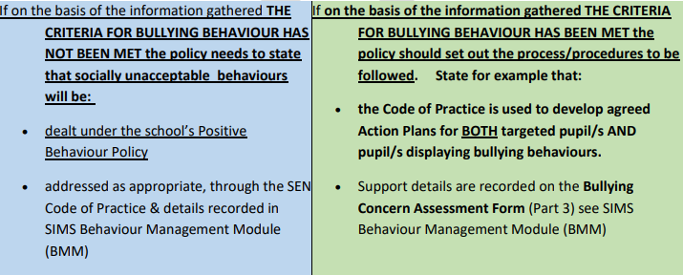

If an incident or issue is not deemed to be bullying, that will be explained to the complainant along with the reasons for that decision. The concern will be dealt with in line with the school’s positive behaviour policy.

If an incident is deemed to be bullying, staff use the following further measures to work towards resolving the issue:
- Identify any themes or motivating factors
- Identify the type of bullying behaviour being displayed
- Identify intervention level
- Select and implement appropriate interventions for all pupils involved, including appropriate interventions, consequences and sanctions.
- Track, monitor and record effectiveness of interventions
- Review outcome of interventions
- Select and implement further intentions as necessary

In the first instance we will attempt to use a restorative approach to resolve bullying issues. If, through discussion, an agreement and acceptance of responsibility is reached, agreement of a resolution will be sought.

In the event of a situation where a satisfactory restorative resolution is not achieved, or in cases where the severity of behaviour is such that it is felt necessary to take a more consequential approach, interventions may include sanctions such as time out, temporary removal of privileges such as play times or participation in events and other sanctions in line with the school’s Behaviour Policy.

Information regarding any action taken regarding a pupil cannot be disclosed to anyone other than that pupil and his/her parents/carers.

10.0 Recording
Schools are legally required, under the Addressing Bullying in Schools Act (NI) 2016 (enacted September 2021) to maintain a record of all incidents of bullying and alleged bullying behaviour.

The school will centrally record all relevant information related to reports of bullying concerns, including:
- how bullying behaviour was displayed (the method)
- the motivation for the behaviour
- how each incident was addressed by the school
- the outcome of the interventions employed

Records will be kept on the online SIMS Behaviour Management Module, which is part of the C2k system in schools. Access to these records will be restricted and only provided to those members of school staff with a legitimate need to have access.

Records will be maintained in line with relevant data protection legislation and guidance and will be disposed of in line with the school’s Retention and Disposal of Documents Policy. Collated information regarding incidents of bullying and alleged bullying behaviour will be used to inform the future development of anti-bullying policy and practice within the school.

11.0 Professional Development of Staff

Scoil na Fuiseoige recognises the need for appropriate and adequate training for staff, including teaching and non-teaching school staff.

The school is committed to providing staff with appropriate opportunities for professional development as part of the school’s ongoing CPD/PRSD provision as resource and operational capacity allows.

Records of training will be maintained as part of the schools in service training log and training will feed into policy review and procedural development.

12.0 Monitoring and Review of Policy
It is the responsibility of the Board of Governors, in liaison with the Principal, to monitor the effectiveness of the Anti-Bullying Policy.

To appropriately monitor the effectiveness of the Anti-Bullying Policy, the Board of Governors shall:

- maintain a standing item on the agenda of each meeting of the Board where a report on recorded incidents of bullying will be noted
- identify trends and priorities for action
- assess the effectiveness of strategies aimed at preventing bullying behaviour
- assess the effectiveness of strategies aimed at responding to bullying behaviour

It is a legal requirement that the Anti-Bullying Policy be reviewed at intervals of no more than four years. It is our intention to review this policy on our standard three year cycle or sooner if any incident or external policy change occurs which highlights the need for such a review or if directed to by the Department of Education and in light of new guidance. The next review should therefore take place in the Autumn of 2024 if not before.

13.0 Links to other school policies

- The Anti-Bullying Policy forms part of the school’s overall Pastoral Care Policy. It links with the Child Protection/Safeguarding Policy in which the school outlines the steps it will take to protect children from harm and develop their personal safety strategies.

- It also links with the school’s E-Safety Policy and Positive Behaviour Policy. The school outlines the types of behaviour which are considered to be appropriate and inappropriate along with the sanctions which will be used as part of the positive behaviour promotion process.

Appendix 1
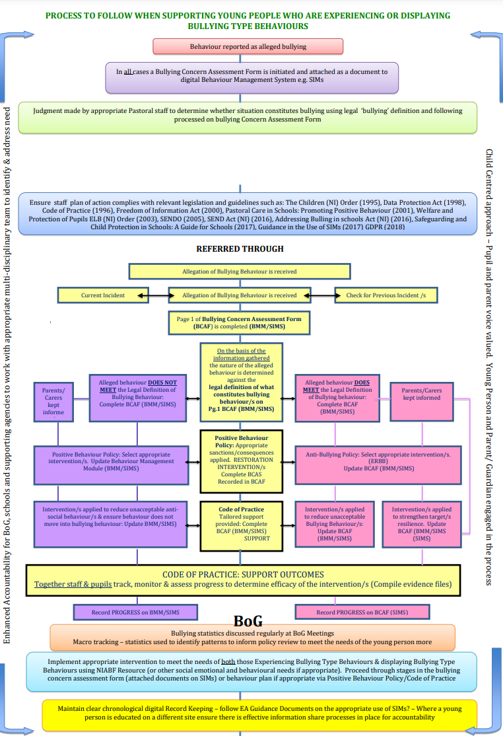

Appendix 2 – Bullying concern assessment form
Incident Date:

Pupils Involved | Role | Incident Date | Gender | DOB | Year and Reg

Incident | Comments
Bullying Concern

PART 1 - Assessment of Concern Date:

Addressing Bullying in Schools Act (Northern Ireland) 2016 defines bullying as follows:

“bullying” includes (but is not limited to) the repeated use of —
(a) any verbal, written or electronic communication
(b) any other act, or
(c) any combination of those,
by a pupil or a group of pupils against another pupil or group of pupils, with the intention of causing physical or emotional harm to that pupil or group of pupils.

 | Name(s) | Gender | DOB/Year Group
Person(s) reporting concern

Name of pupil(s) experiencing alleged bullying behaviour

Name of Pupil(s) demonstrating alleged bullying behaviour

Check records for previously recorded incidents

Outline of incident(s): Attach all written accounts/drawings of incident(s) completed by targeted pupil, witnesses (i.e. other pupils, staff) including date(s) of events, if known, SIMS record.
Date | Information gathered | Location (stored)

Socially unacceptable behaviour becomes bullying behaviour when, on the basis of the information gathered, the criteria listed below have been met:
The school will treat any incident which meets these criteria as bullying behaviours.
Is the behaviour intentional? | YES / NO
Is the behaviour targeted at a specific pupil or group of pupils? | YES / NO
Is the behaviour repeated? | YES / NO
Is the behaviour causing physical or emotional harm? | YES / NO
Does the behaviour involve omission? (*may not always be present) | YES / NO

One-off Incident

When determining whether a one-off incident may be classified as bullying, the school shall take into consideration the following criteria and use the information gathered to inform and guide the decision making process:

Criteria: | Information gathered:
severity and significance of the incident
evidence of pre-meditation
Significant level of physical/emotional impact on individual/s
Significant level of impact on wider school community
Status/nature of previous relationships between those involved
Records exist of previous incidents involving the individuals

YES the above criteria have been met and bullying behaviour has occurred. | NO the above criterial have not been met and bullying behaviour has not occurred.
The criteria having been met, proceed to complete Part 2 of this Bullying Concern Assessment Form | The criteria having not been met, proceed to record the details in the Behaviour Incident section of this Behaviour Management Module. Refer to the Positive Behaviour Policy of your school, continue to track and monitor to ensure the behaviour does not escalate .
Agreed by ___________________________
Status ____________________________
On ___/___/___

PART 2

2:1 Who was targeted by this behaviour?
Select one or more of the following:
Individual to individual 1:1 Individual to group Group to individual Group to group
2.2 In what way did the bullying behaviour present?

Select one or more of the following:

Physical (includes for example, jostling, physical intimidation, interfering with personal property,
punching/kicking
Any other physical contact which may include use of weapons)
Verbal (includes name calling, insults, jokes, threats, spreading rumours)
Indirect (includes omission, isolation, refusal to work with/talk to/play with/help others)
Electronic (through technology such as mobile phones and internet)
Written
Other Acts
Please specify:__________________________________________________-

2.3 Motivation (underlying themes): this is not a definitive list

Select one or more of the following:

Age
Appearance
Cultural
Religion
Political Affiliation
Community background
Gender Identity
Sexual Orientation
Family Circumstance (pregnancy, marital status, young carer status)
Looked After Status (LAC)
Peer Relationship Breakdown
Disability (related to perceived or actual disability)
Ability
Pregnancy
Race
Not known
Other ______________________________________________________________

Part 3a

RECORD OF SUPPORT AND INTERVENTIONS FOR PUPIL EXPERIENCING BULLYING BEHAVIOUR:
Pupil Name: Year Group/Class:
REFER TO SCHOOL ANTI-BULLYING POLICY AND TO LEVEL 1-4 INTERVENTIONS IN EFFECTIVE RESPONSES TO BULLYING BEHAVIOUR
Parent/ carer informed: Date: By whom:

Staff Involved:

Date | Stage on Code of Practice | Intervention | Success Criteria | Action taken by whom and when | Outcomes of Intervention | Review

Record of participation in planning for interventions
Pupil:

Parent/carer:

Other Agencies:

Continue to track interventions until an agreed satisfactory outcome has been achieved
RECORD OF SUPPORT AND INTERVENTIONS FOR PUPIL DISPLAYING BULLYING BEHAVIOUR:
Part 3b
Pupil Name: Year Group/Class:
REFER TO SCHOOL ANTI-BULLYING POLICY AND TO LEVEL 1-4 INTERVENTIONS IN EFFECTIVE RESPONSES TO BULLYING BEHAVIOUR
Parent/ carer informed: Date: By whom:

Staff Involved:
Date | Stage on Code of Practice | Type of Intervention | Success Criteria | Action taken by whom and when | Outcome of Intervention | Review

Record of participation in planning for interventions
Pupil:

Parent/carer:

Other Agencies:

Continue to track interventions until an agreed satisfactory outcome has been achieved

PART 4 - REVIEW OF BULLYING CONCERN AND ACTIONS TO DATE
Date of Review Meeting:
4a- Following the Review Meeting, to what extent have the success criteria been met?
1 – Fully
2 – Partially
3 – Further intervention/support required
Give details: ___________________________________________________________________________________________________________________________________________
Part 4b- If the success criteria have not been met, continue to:
Re-assess Level of Interventions and implement other strategies from an
appropriate level
Track, monitor and review the outcomes of further intervention
Keep under review the Stage of Code of Practice each pupil is on
Follow Safeguarding Policy
Seek multi-agency input (EA, Health and Social Services etc.)
Engage with Board of Governors
Agreed by:
School | Signed:  Date:
Parent | Signed:  Date:
Pupil | Signed:  Date:

