Polasaí Tinrimh agus Poncúlachta
Attendance and Punctuality Policy

SCOIL NA FUISEOIGE

INTRODUCTION
Regular school attendance is crucial in raising standards in education and ensuring that every child can have full access to the school curriculum and reach their potential. Scoil na Fuiseoige will strive to promote an ethos and culture which encourages good attendance and where each pupil will feel valued and secure. The Pastoral care of our children is central to the aims, ethos and teaching programmes in Scoil na Fuiseoige. We are committed to developing positive and caring attitudes in our children, staff and other members of our school community. Our Attendance Policy is part of our collective Pastoral Care policies. To accurately record and monitor attendance in a consistent way we will adhere to the guidance provided in the Department of Education Circular 2021/16, which can be found at the following link:
https://www.education-ni.gov.uk/publications/circular-202116-attendance-guidance-and-absence-recording-by-schools
SCHOOL ROUTINES
In Scoil na Fuiseoige we wish every child to have a positive and orderly start to their school day. Maintaining excellent attendance and coming to school on time helps to ensure routines are well established and our pupils can make good progress. To ensure the above we have a clear set of school routines which we expect all parents and pupils to follow:
• Pupils may enter the school from 9.00 am- at this time members of staff are on duty and can ensure appropriate supervision.
• The school day starts at 9.15 am - we expect all children to be in class at this time.
• Any child arriving to school after 9.15 am is late.
• A child arriving to school after 9.15 am will need to come to the main school entrance. Parents are welcome to escort their child to the Reception Area. The Secretary will give the child access to the school building.

PRINCIPLES OF ATTENDANCE POLICY
We believe that high levels of attendance are directly linked to pupil attainment and fulfilling potential. Excellent attendance and a punctual start to the school day are important to all children and the smooth running of our school. Scoil na Fuiseoige will encourage parents/carers to ensure that their child achieves maximum possible attendance and that any problems which prevent this are identified and addressed quickly.
Children who regularly miss school without good reason are more likely to become isolated from their peers and friends or to underachieve in examinations.

AIMS
1. To improve/maintain the overall attendance of pupils at Scoil na Fuiseoige.
2. To develop a framework that defines roles and responsibilities in relation to attendance.
3. To provide advice, support and guidance to parents/guardians and pupils.
4. To promote good relationships with the Education Welfare Service.

OUR EXPECTATIONS
- All pupils will attend school every day
- Pupils will attend school punctually
- Our pupils will attend school prepared for the day (e.g. Homework complete, PE Kit, Reading Books, Healthy Break etc)

ROLE OF PARENTS, CARERS AND GUARDIANS
Parents/guardians have a legal duty to ensure their child of compulsory school age shall receive efficient full-time education suitable to age, ability and aptitude and to any special educational needs they may have, either by regular school attendance or otherwise. If a child is registered in school, their parent/guardian has a legal duty to ensure that they regularly attend that school.

Pupils are expected to be in school at 9.15am for registration and the beginning of classes. It is the responsibility of parents/guardians to ensure that your child is punctual. Lateness is recorded at registration and on your child’s attendance record.
If your child appears reluctant to attend school, please discuss the matter promptly with the class teacher or Principal to ensure that both you and your child receive maximum support.

Scoil na Fuiseoige;
- Provide a welcoming atmosphere
- Provide a safe and structured learning environment
- Keep regular and accurate attendance and punctuality records and monitor each individual child’s attendance and punctuality
- Promote good attendance and punctuality and reduce absence through a system of reward and recognition
- Regularly inform parents/carers of the % attendance of all pupils
- Where appropriate, inform parents/carers via school letters regarding their child’s/children’s poor attendance and punctuality- refer to appendix
- Act to address patterns of absence
- Ensure that every pupil has access to education to which they are entitled
- Endeavour to keep in contact with a parent where there is a prolonged absence

PROMOTING AND CELEBRATING GOOD ATTENDANCE
- Monthly Class Attendance- each month the class with the highest % attendance is recognised and rewarded- certificates are presented in Assembly
- Monthly Most Improved Class Attendance
- At the end of the academic year 100% Attendance Certificated will be presented

NOTIFYING ABSENCES
From time-to-time children may need to be absent from school for other reasons such as medical appointments. Such absences usually only take up part of the school day. School should be informed of such absences in advance by phoning the school, and children should be brought into school for morning registration and back to school after the appointment. Every effort, however, should be made to arrange medical appointments outside school hours. Every day a child is absent from school equates to a day of lost learning.

The Tables shows the DENI Guidance, School Attendance Matters- A Parent’s Guide
https://www.education-ni.gov.uk/sites/default/files/publications/de/attendance-matters-a-parents-guide.pdf
https://www.education-ni.gov.uk/sites/default/files/publications/de/attendance-matters-a-parents-guide-irish.pdf

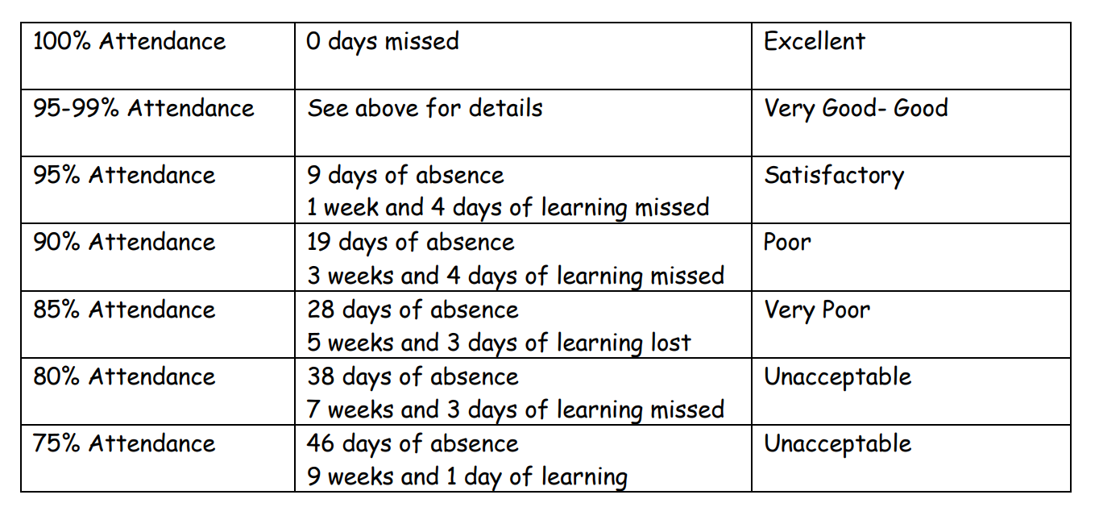
EDUCATION WELFARE SERVICE
The Education Authority through the Education Welfare Service (EWS) have a legal duty to make sure that parents/guardians meet their responsibility towards their children’s education. If a pupil’s absence causes concern, or if their attendance falls below 85% and there is also a concern, they will be referred to the EWS, if appropriate. EWS will support staff and parents in developing and implementing strategies to address or improve school attendance.

UNAUTHORISED ABSENCES
Unauthorised absences are those which the school does not consider reasonable and for which no ‘leave’ has been given. Examples of unauthorised absences are:
• Parents/carers keeping children off unnecessarily
• Unexplained absences i.e. an absence which has not been explained to the school
• Shopping
• Looking after other children
• Birthdays
• Day trips or holidays during term time
• Truancy
HOLIDAYS DURING TERM TIME
Holidays taken during term time will be categorized as unauthorized absenses. Under current guidance from DENI Scoil na Fuiseoige may not grant leave of absence during term time unless there are exceptional circumstances. Therefore, our school will only authorise holidays in line with this guidance. Exceptional circumstances will only be granted very rarely. Parents/carers should inform the school via letter if they are going on holiday. Although we cannot authorise this absence we appreciate the courtesy.

PERSISTENT ABSENTEEISM
The school will continually monitor the attendance of all pupils. In Scoil na Fuiseoige we follow a two-stage process to support pupils who are persistently absent for any reason:
- Each month the Pastoral Care Leader will review all absences and the reasons given for those children who fall below 85% as a cumulative percentage since the beginning of the academic year. Trends in absenteeism is looked for such as improving or declining attendance from the previous month or if there are certain days of the week where individuals are absent more often. Following this analysis a range of actions may result:

School may phone parents to discuss the matter and offer support with a view of attendance increasing. Very often interventions at this early stage can have a positive impact on pupil attendance and no further action is required.

- Following from the first stage if no improvement is evident the list of children whose attendance which is below 85% is discussed with the Education Welfare Officer and a referral will be discussed or agreed.

The Pastoral Care Leader will liaise with the class teacher, Principal and other professionals if the need for support is identified.

PUNCTUALITY, REGISTERS AND LATENESS
Punctuality to school is crucial. Lateness to school causes disruption to that individual’s learning and to that of other pupils in the class. It is paramount therefore that all pupils arrive to school on time. Registers are taken by teachers at the start of the school day.

Teachers must record the attendance of each child in their class on SIMS. Teachers should complete the register by 9.30am.
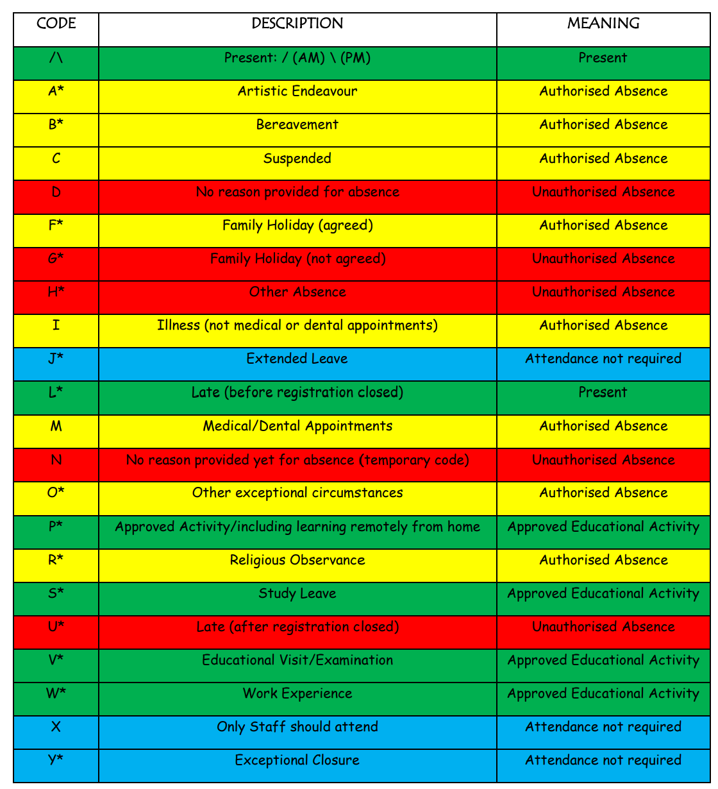
The following registration codes may be used:

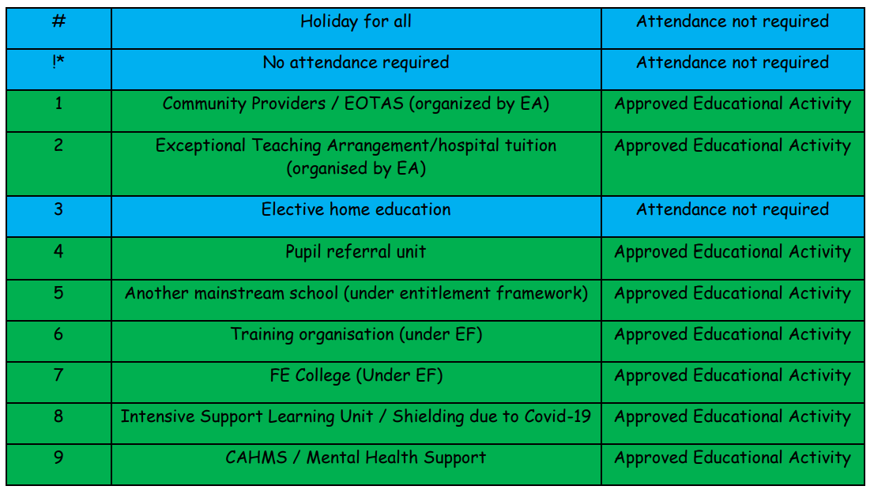

*The use of this code is at the discretion of the school
Present / Approved Educational Activity Codes
Attendance not required codes
Authorised Absences Codes
Unauthorised Absence Codes

A child who is late in to school will receive an ‘L’ code (Late) for that day. If a child does not arrive in to school an ‘N’ code is used. This indicates an unauthorised absence and will be recorded as such on a child’s record showing that ‘no reason’ has been provided for the absence. However, in on return to school where a reason is provided the N code will then be changed e.g. I for illness. If a child arrives to school late the ‘L’ code will be used.

LATENESS
Poor punctuality is not acceptable. A child arriving to school after 9.15 am will need to enter school via the main entrance. In the case of very persistent lateness the Pastoral Care Leader will contact the parents/carers to suggest a way forward.

Attendance Letter 1

Date:
ADDRESS
Dear ,

RE: NAME OF PUPIL AND DOB

Throughout the school year I am required to monitor the attendance of all pupils in our school. I am obliged by law to pass to the Education Welfare Officer the names of children whose attendance persistently falls below 85%.
At present (pupils name) attendance at school since September 20XX stands at XX%
The Education Welfare Officer has advised me to write to you to draw your attention to this matter. It is hoped with your support (pupil’s name) attendance will increase in the coming weeks.
All staff here in Scoil na Fuiseoige are very supportive of (pupil name) and wish to see (him/her) achieve their full potential. If you would like to discuss how we can be of any further help, please do not hesitate to contact me.

Yours Sincerely

Pastoral Care Leader

Attendance Letter 2

Date:
ADDRESS
Dear ,
RE: NAME OF PUPIL AND DOB
I wrote to you recently sharing our concerns with (pupil’s name) attendance at school. Since this first review (pupil’s name) attendance unfortunately has not improved. Our records show that there are XX unauthorised absences for your child.
At present (pupils name) attendance at school since September 20XX stands at XX%
Following a further review with the Education Welfare Officer I have been advised to inform you that your child has been referred to the Education Welfare Service. This is a supportive service which acts with a view to increase attendance at school enabling our pupils to reach their full potential.
All staff here in Scoil na Fuiseoige are very supportive of (pupil name) and wish to see (him/her) achieve their full potential. If you would like to discuss how we can be of any further help, please do not hesitate to contact me.
Yours Sincerely

Principal

