POLICY FOR THE ADMINISTRATION OF MEDICATION IN SCHOOL

SCOIL NA FUISEOIGE

This policy is in line with the guidance detailed in the Supporting Pupils with Medication Needs (2008) document published by the Department of Education N.I. and the Department of Health, Social Services and Public Safety.

INTRODUCTION

Most pupils will at some time have a medical condition that may affect their participation in school activities. For many this will represent a short term medical need; perhaps finishing a course of medication, as a result of an accident or recovering from illness. Some other pupils may require medication on a long term basis to keep them well, for example children with well controlled epilepsy or cystic fibrosis and, if this is not properly managed, they could be prevented from reaching their full potential. Such pupils are regarded as having medical needs. Most children with medication needs are able to attend school regularly and, with some support from the school, can take part in the majority of school activities. A positive response by the school to a pupil’s medication needs will not only benefit the pupil directly, but can also positively influence the attitude of others.

Medication needs can be grouped into three categories:

- Pupils requiring short term prescribed medication for acute conditions, for example an ear or chest infection. Usually such children will have been off school, but may still be on medication when they return.
- Pupils with a long term condition requiring regular medication; the two biggest categories within this group would be children with asthma and those with ADHD.
- Pupils who may very rarely require medication to be given in an emergency: Two different types of medical emergency may arise within the school setting:

- Where the pupil has not previously been known to have a medical condition and the
medical emergency arises “out of the blue”.

- Where a pupil with a known medical condition and a Medication Plan experiences a medical emergency in the context of their condition, such as children with severe allergies who may need an adrenaline injection.

Within each of these categories medication may be self-administered, supervised, or administered by a third party. The most challenging situations for schools are for the child on long term medication and the child requiring a drug in an emergency.
POLICY FOR THE ADMINISTRATION OF MEDICATION IN SCHOOL

The Board of Governors and staff of Scoil na Fuiseoige wish to ensure that pupils with medication needs receive appropriate care and support at school.

At Scoil na Fuiseoige we recognise 2 categories of required prescribed medications, namely:
1 Long-term medications eg for asthma, diabetes epilepsy or anaphylaxis (nut allergy- epipen)
2 Short-term medications eg antibiotics.

Long-Term Medications
Staff at Scoil na Fuiseoige agree to store inhalers for asthma sufferers who are able to administer the drug themselves, provided that parents provide comprehensive information on the administration of the medication. This information should include:

1 The name of the drug.
2 The amount required.
3 The regularity of the dose.
4 Exactly what procedure should be followed in the case of an emergency.

This information will be made available to all staff who may come into contact with the child during the course of a school day.

Scoil na Fuiseoige agree to store glucose necessities for children suffering from diabetes provided that information is provided as outlined above.

Scoil na Fuiseoige agree to store epipens for children who have allergies. Staff are provided with training on how to use the epipen by the school nurse.

A medical action plan will be drawn up in conjunction with the school nurse for any child that requires long-term medications.

Short-Term Medications

Medication should only be taken to school when absolutely essential and with the agreement of the Principal. Parents should be encouraged to request, where possible, that medication be prescribed in dose frequencies which enable it to be taken outside school hours e.g. medicines that need to be taken three times a day could be taken in the morning, after school hours and at bedtime.

Medication will only be administered in school if the parent / carer has signed a consent form. The medication required by a child will be stored in the school Office. The Principal / Vice-Principal / School Secretary will follow DE guidance and the schools Health and Safety Policy when required to administer medication.

Please note that parents should keep their children at home if acutely unwell or infectious.

Only reasonable quantities of medication should be supplied to the school (for example, a maximum of four weeks supply at any one time).

Each item of medication must be delivered to the Principal/Vice-Principal or Secretary, in normal circumstances by the parent/carer, in a secure and labelled container as originally dispense

Each item of medication must be clearly labelled with the following information:

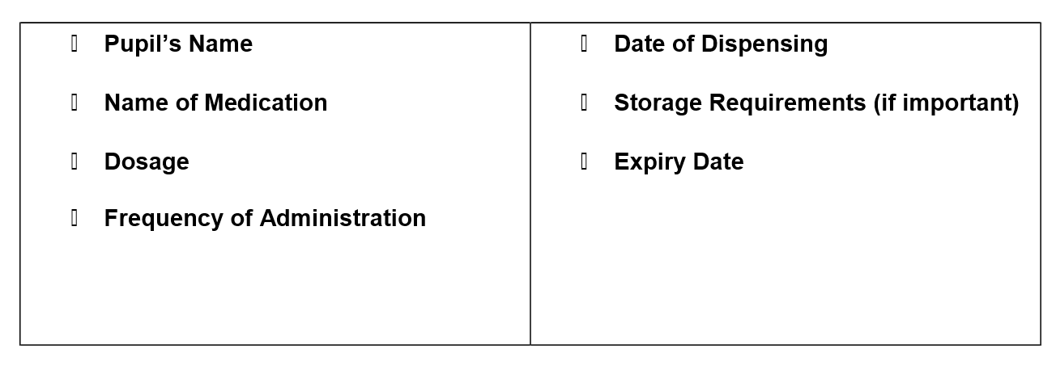

The school will not accept items of medication in unlabelled containers.

Medication for long term medical needs will be kept safely in the staffroom in clearly labelled Medical Bags/Containers. Other medication to be administered in school may be stored securely in the school office.

The school will keep records of medicines administered.

If children refuse to take medicines, staff will not force them to do so, and will inform the parents/carers of the refusal, as a matter of urgency, on the same day. If a refusal to take medicines results in an emergency, the school’s emergency procedures will be followed.

It is the responsibility of parents/carers to notify the school in writing if the pupil’s need for
medication has ceased.

It is the parents’/carers’ responsibility to renew the medication when supplies are
running low and to ensure that the medication supplied is within its expiry date.

The school will not make changes to dosages on parental instructions.

School staff will not dispose of medicines. Medicines, which are in use and in date, should be collected by the parent at the end of each term. Date expired medicines or those no longer required for treatment will be returned immediately to the parent for transfer to a community pharmacist for safe disposal.

For each pupil with long term or complex medication needs, the Principal/SENCO, will ensure that a Medication Plan and Protocol is drawn up, in conjunction with the appropriate health professionals.

Where it is appropriate to do so, pupils will be encouraged to administer their own medication, if necessary under staff supervision.

The school will make every effort to continue the administration of medication to a pupil whilst on trips away from the school premises, even if additional arrangements might be required. However, there may be occasions when it may not be possible to include a pupil on a school trip if appropriate supervision cannot be guaranteed.

All staff will be made aware of the procedures to be followed in the event of an emergency.

